# Prerequisites

## EVB-A

User must have procured the InnoPhase Talaria TWO evaluation board, and a USB cable to connect the evaluation board to the PC. Though this document specifically describes the use of the GUI on a Windows platform, the procedure is similar for Linux OS as well.

Application T2DownloadTool_Windows.exe is for Windows platform while T2DownloadTool_Linux is for the Linux OS.

## Using Download Tool in Linux

There are two ways in which the T2DownloadTool_Linux can be used in Linux:

1. Run the T2DownloadTool_Linux tool from terminal with sudo command. For example:

|  |
| --- |
| sudo /sdk_x.y/pc_tools/Download_Tool/bin/T2DownloadTool_Linux |

**Note**: x and y in sdk_x.y refers to the SDK release version. Replace x and y with the appropriate SDK release version.

1. Double click on T2DownloadTool_Linux.

Add udev rules and folder access permission to enable double click feature. Execute the following steps:

Step 1: Create Libusb_T2.rules file in */etc/udev/rules.d* directory.

Step 2: Add the following rules to Libusb_T2.rules file.

**Libusb_T2.rules:**

|  |
| --- |
| SUBSYSTEMS==”usb”, ATTRS{idVendor}==”0403”, ATTRS{idProduct}==”6011”, GROUP=”users”, MODE=”0666” |

In case of Permission Denied error, execute the following step (Step 3) to extend folder access permission.

Step 3: Run the following command in the terminal to extend permissions to the selected folder and its files.

|  |
| --- |
| sudo chmod -R a+rwxRWX /Path/to/sdk folder |

## Microsoft Visual C++ Redistributable Software Package

Microsoft Visual C++ Redistributable software package is a prerequisite for Windows platform to run the application T2DownloadTool_Windows.exe successfully. Incase this software package is not installed on the Windows platform, application will not launch, leading to a fatal error message as shown in Figure 1. In such a scenario, install the Microsoft Visual C++ Redistributable software package and relaunch the application.

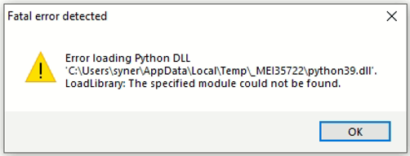

Figure 1: Error message for missing Microsoft Visual C++ Redistributable Software Package

## Driver Installation for Windows OS

On Windows OS, libusbK driver needs to be installed to communicate and control the Talaria TWO module via the FTDI device on the evaluation board. The tools/applications provided by InnoPhase will communicate using this driver.

Download tool comes with an option of One-Click Installation of libusbk driver. In case the driver is not installed, the tool will ask for user confirmation to install this driver. If the user selects yes, various User Account Control authentication screens will appear to complete the driver installation (as shown in Figure 4).

**Note**:

1. In case of any other unwanted libusbk drivers that are already installed, tool will automatically uninstall the unwanted drivers. This action needs User Account Control authentication screens shown in Figure 5, in addition to Figure 4. Each unwanted drives will require a separate User Account Control authentication for uninstallation.
2. Talaria TWO Evaluation Board may get detected under any already installed device driver (using libusbk driver). In this case, the tool will follow the procedure of One-Click Installation of libusbk driver (as shown in Figure 4), and might get completed with a pop-up message “Driver Installation Failed”. This will result in any one of the following two conditions:
   1. Device found: EVK serial number field in the download tool GUI is populated with appropriated EVK serial number. In this case, ignore the error message “Driver Installation Failed” and continue using the tool. To avoid this from happening repeatedly, update the driver for Talaria TWO Evaluation Board to “InnoPhase T2 Evaluation Board” driver, from device manager (as shown in Figure 2). Then, ensure the Talaria TWO Evaluation Board is detected under “libusbK USB Devices” in device manager (as shown in Figure 3).

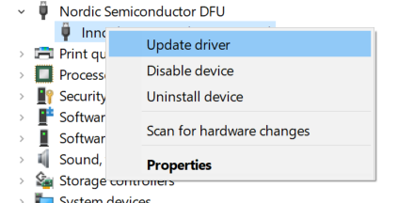

Figure 2: Update device driver for Talaria TWO Evaluation Board

* 1. No device found: Manually install the driver using instructions from section: Installation instructions for libusbK driver and ensure that Talaria TWO Evaluation Board is detected under libusbK USB Devices driver (as shown in Figure 3).

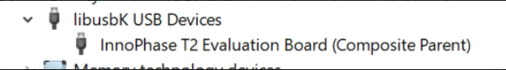

Figure 3: Talaria TWO Evaluation board under "libusbk USB Devices” driver

1. Even after successful installation of the driver, there might be possibility of the device not being identified for the first time. In this case, close the tool and re-open it. The user is notified of the same through a pop-up message: “No Device Connected. Please close and reopen the Tool.”.

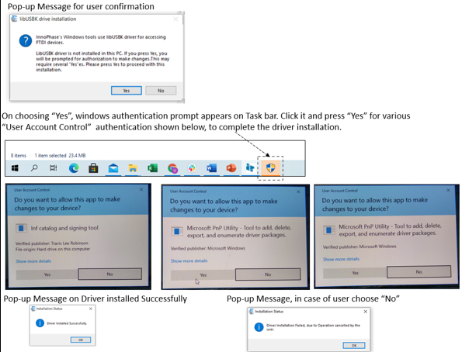

Figure 4: User Account Control authentication to complete driver installation

Figure 5: User Account Control authentication to delete the unwanted Libusbk drivers

In case the driver installation using the Download Tool is not successful, the user can manually install the driver by following the instructions provided in section: Installation instructions for libusbK driver. Instructions to change driver is available in section: Update Driver from libusbK to COM Port.